**Wellington City Newsletter**

**June 2016**

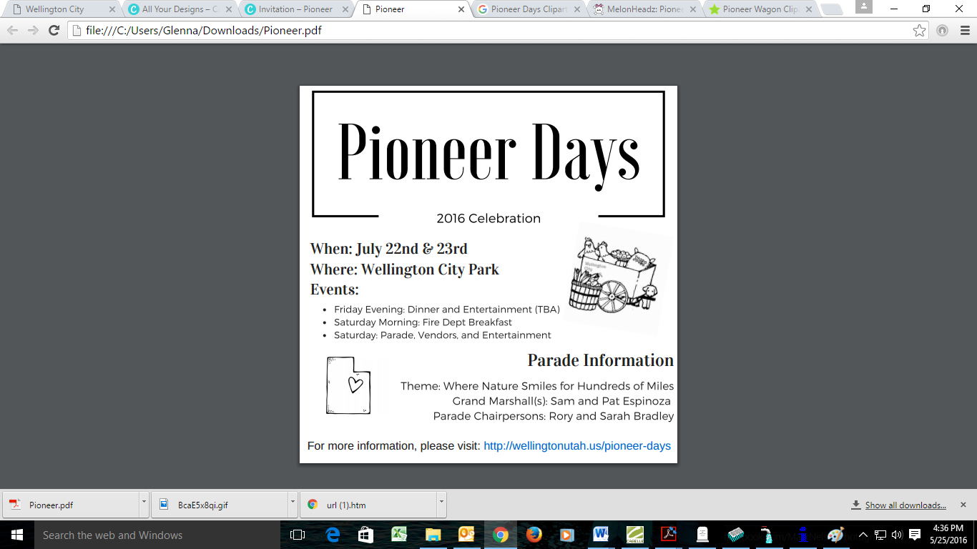

**Post-Memorial Cemetery Clean-Up**

Wellington City will have its annual post-memorial day clean up June 6, 2016. Please remove any items you wish to keep before that date.

**Pee-Wee Baseball Schedule**

Wellington City Pee-Wee Baseball has four teams playing this season. Games will be played every Tuesday and Thursday in June at 6:00pm and 7:00pm. On June 30th the teams will have a party to close out the season. For a complete schedule, please visit <http://www.wellingtonutah.us/Pee-Wee-Baseball>

**WELLINGTON CITY 2016 WATERING SCHEDULE**

Last year’s rotating water schedule allowed the water to keep in the pond, and kept the pumps from overheating. Therefore Wellington City will continue with a rotating water schedule for the upcoming season. In an effort to give everyone a chance to water on the weekends, we will mix up the schedule this year. Should we have a schedule again next year, we will do the same.

The official watering schedule for the 2016 season will be as follows:

* Monday & Thursdays: residents North of Main Street/Highway 6
* Tuesdays & Fridays: residents South of Main Street/Highway 6
* Wednesdays & Saturdays: residents North of the City Cemetery

Please try to avoid running the water between 11:00am to 5:00pm, as we know the lawn benefits more when watered at cooler hours of the day. Also remember to move the water every 30 minutes.