Wellington City Newsletter
May 2018

“Springtime is coming, is coming today. For I hear a robin, who was calling her this way,” anyone else remember that childhood song? I have noticed many residents are preparing their garden spots and cleaning up the yard. ‘Tis the Season, and we encourage everyone to clean up and spruce up their yards.

During the past three years, even during our wetter one last year, Wellington City had water turns. While it has helped in years’ past with the draw on the holding pond, it has also helped to conserve water. At the point in time the watering turns are voluntary. Depending on the weather during the summer months, it may become mandatory. This year’s water rotation is as follows:

Monday and Thursday: North of the Cemetery
Tuesday and Friday: North of Main Street
Wednesday and Saturdays: South of Main Street.

Kings goes a long way in making others feel good. Randy Thayn, Sam Espinoza, and Dale Mathis have teamed up to help community. The trio is donating time and resources to establish a community garden in Wellington. They have worked together to prepare a ¾ acre lot to grow produce for later enjoyment. The lot sits to the west of the Foxbourough Apartments. Three watering points have been established for ease of watering the garden, and watering schedule outlined above is to be followed.

The Pioneer Day Celebration is in good hands this year. Councilmember Willson is over the celebration, and Rory and Sarah Bradley have agreed to chair the Pioneer Day Celebration Committee. Already they have a great team lined up to help this with this event. The theme this year is, “Reflecting Back, Looking Forward, Celebrating 140 Years of Wellington.”

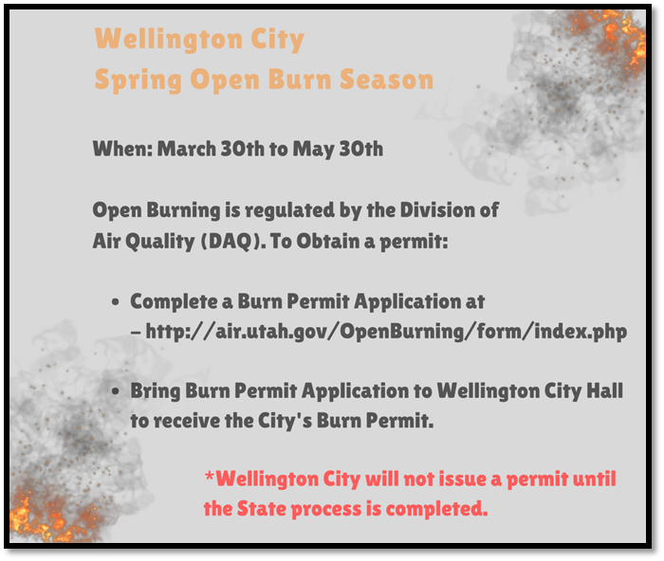
We want to recognize and show appreciation for the volunteers on the Wellington City Fire Department. Not only were they helpful during the Annual Easter Egg Hunt, but they have been instrumental in the burning of debris piles for the Price River Clean-Up Project. This volunteer time counts as the City’s “in-kind” match for the money allocated from the NRCS for this project. The City however is most grateful and thankful for their “round the clock” efforts during the recent Price River Water Improvement District line break near the Carbon County Golf Course. Because of their effort to continually pump water being provided by Price City, Wellington City did not suffer a “loss of service”. THANK YOU SO VERY MUCH WELLINGTON CITY FIRE DEPARTMENT! Also, we are so grateful to Price City for helping address the needs of citizens outside of their boundaries.

Memorial Day is May 28, 2018. If anyone would have time to help at the Cemetery before Memorial Weekend, please contact Paula Noyes at 435-650-1710. A service honoring Veterans will be held on Memorial day at 11 A.M. at the Wellington City Cemetery.

